Task 10: Enhance the task 8 (refer session 19, assignment 1) to calculate the top 3 state-wise sales for each company. You may use multiple reducers for this activity.

DRIVER CLASS:

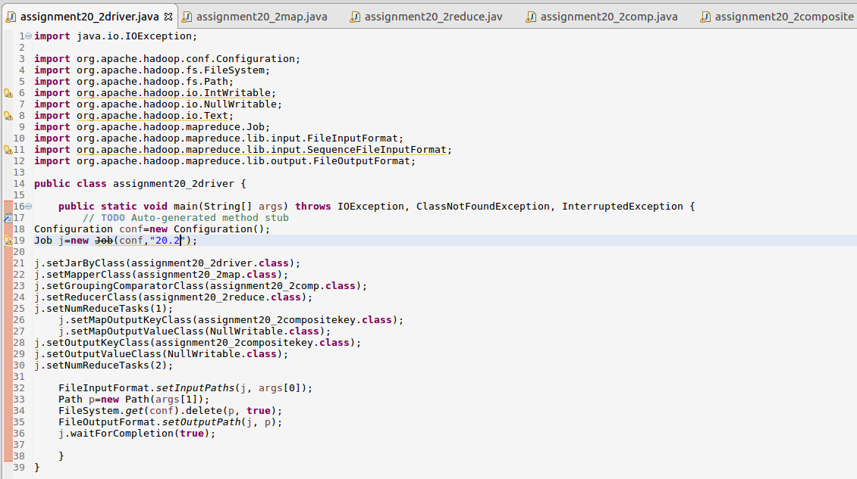

MAPPER CLASS:

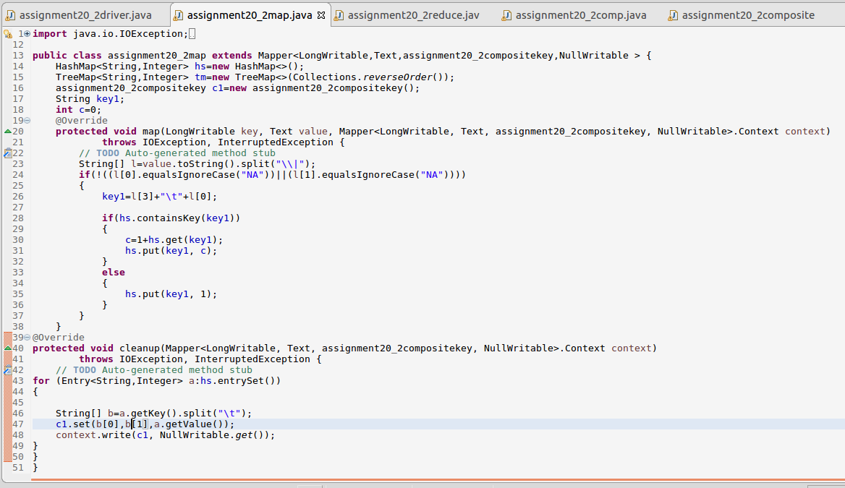

REDUCER CLASS:

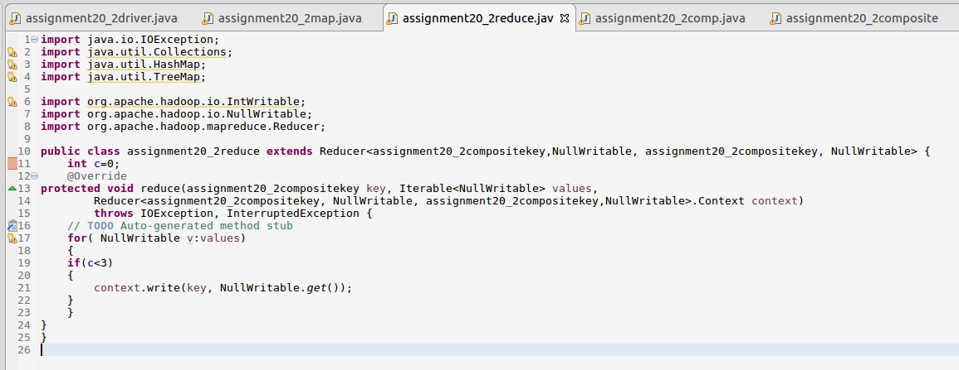

WRITABLE COMPARABLE:

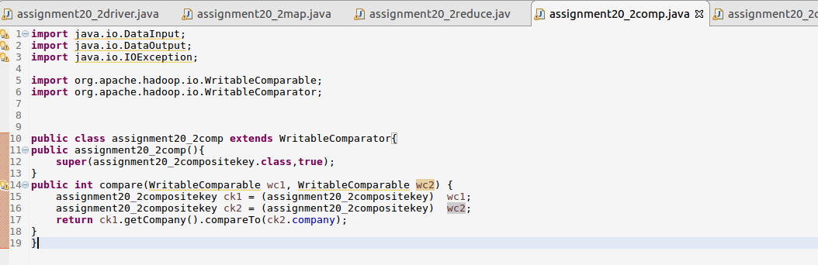

COMPOSITE KEY:

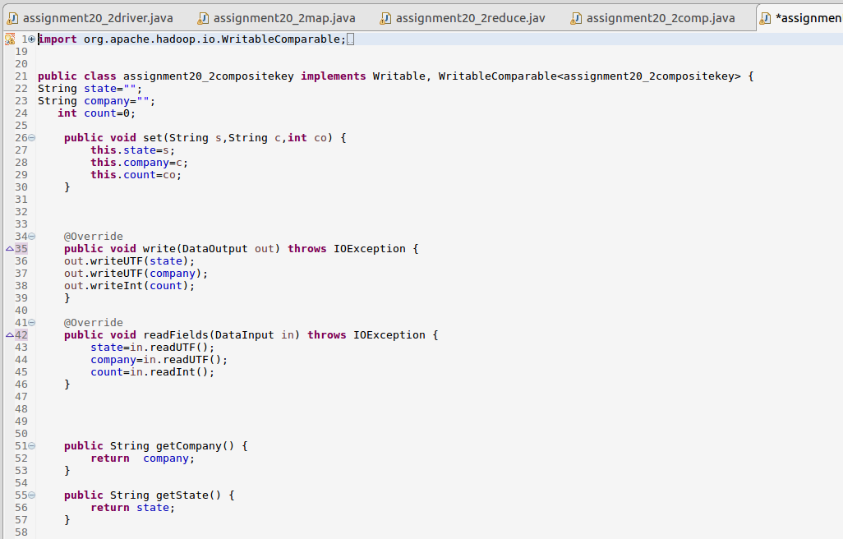

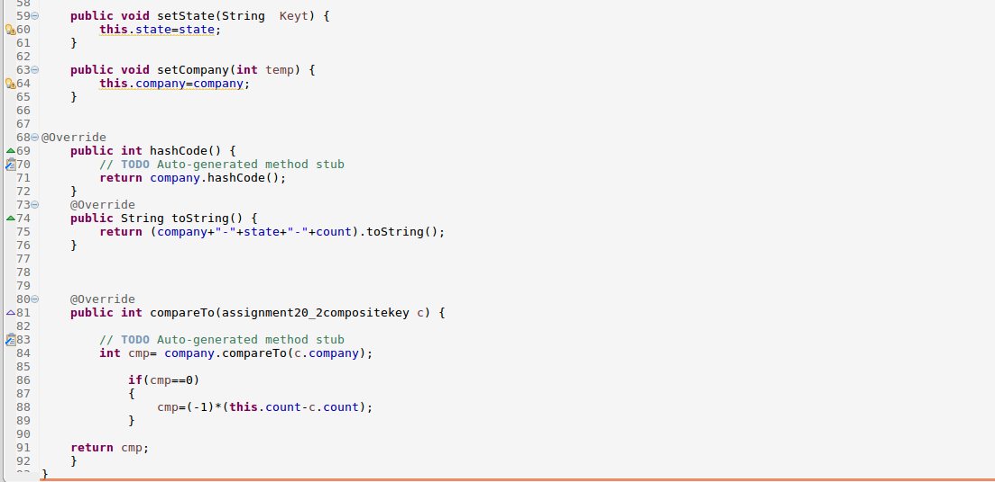

RUNNING JAR:

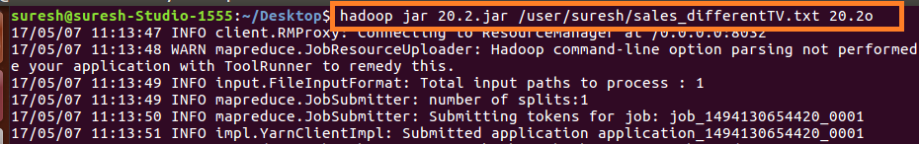

OUTPUT:

